BÁO CÁO THỰC HÀNH
IT3280 – 147793 – THỰC HÀNH KIẾN TRÚC MÁY TÍNH
Tuần 11: Interrupts & IO programming
Họ và tên | Lê Đồng Cảnh Phú
Mã số sinh viên | 20225755

Assignment 1
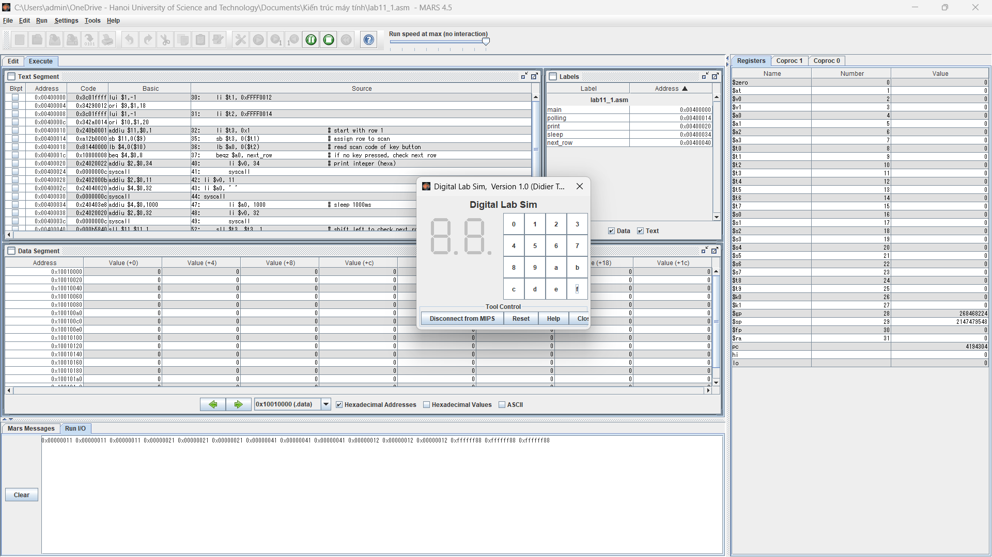
# Laboratory Exercise 11, Assignment 1
#------------------------------------------------------
# col 0x1 col 0x2 col 0x4 col 0x8
#
# row 0x1 0 1 2 3
# 0x11 0x21 0x41 0x81
#
# row 0x2 4 5 6 7
# 0x12 0x22 0x42 0x82
#
# row 0x4 8 9 a b
# 0x14 0x24 0x44 0x84
#
# row 0x8 c d e f
# 0x18 0x28 0x48 0x88
#
#------------------------------------------------------
# command row number of hexadecimal keyboard (bit 0 to 3)
# Eg. assign 0x1, to get key button 0,1,2,3
# assign 0x2, to get key button 4,5,6,7
# NOTE must reassign value for this address before reading,
# eventhough you only want to scan 1 row
.eqv IN_ADRESS_HEXA_KEYBOARD 0xFFFF0012
# receive row and column of the key pressed, 0 if not key pressed
# Eg. equal 0x11, means that key button 0 pressed.
# Eg. equal 0x28, means that key button D pressed.
.eqv OUT_ADRESS_HEXA_KEYBOARD 0xFFFF0014
.text
main:
li $t1, IN_ADRESS_HEXA_KEYBOARD
li $t2, OUT_ADRESS_HEXA_KEYBOARD
li $t3, 0x1 # start with row 1

polling:
sb $t3, 0($t1) # assign row to scan
lb $a0, 0($t2) # read scan code of key button
beqz $a0, next_row # if no key pressed, check next row

print:
li $v0, 34 # print integer (hexa)
syscall
li $v0, 11
li $a0, ' '
syscall

sleep:
li $a0, 1000 # sleep 1000ms
li $v0, 32
syscall

next_row:
sll $t3, $t3, 1 # shift left to check next row
ble $t3, 0x8, polling # loop until all rows checked
j main # restart from row 1

Assignment 2
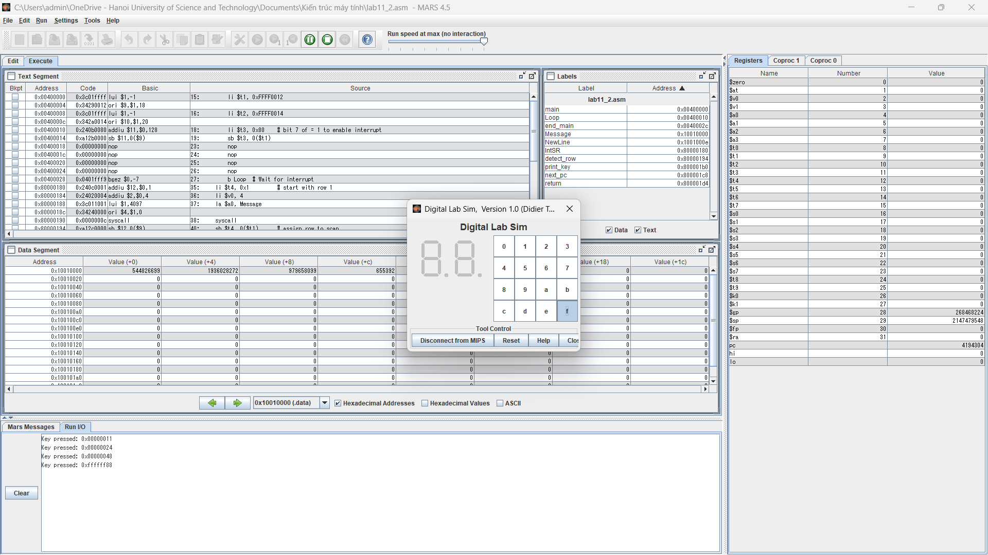
.eqv IN_ADRESS_HEXA_KEYBOARD 0xFFFF0012
.eqv OUT_ADRESS_HEXA_KEYBOARD 0xFFFF0014
.data
Message: .asciiz "Key pressed: "
NewLine: .asciiz "\n"
#~~~~~~~~~~~~~~~~~~~~~~~~~~~~~~~~~~~~~~~~~~~~~~~~~~~~~~~~~~~~~~~~~
# MAIN Procedure
#~~~~~~~~~~~~~~~~~~~~~~~~~~~~~~~~~~~~~~~~~~~~~~~~~~~~~~~~~~~~~~~~~
.text
main:
#---------------------------------------------------------
# Enable interrupts you expect
#---------------------------------------------------------
# Enable the interrupt of Keyboard matrix 4x4 of Digital Lab Sim
li $t1, IN_ADRESS_HEXA_KEYBOARD
li $t2, OUT_ADRESS_HEXA_KEYBOARD
Loop:
li $t3, 0x80 # bit 7 of = 1 to enable interrupt
sb $t3, 0($t1)
#---------------------------------------------------------
# No-end loop, main program, to demo the effective of interrupt
#---------------------------------------------------------
nop
nop
nop
nop
b Loop # Wait for interrupt
end_main:
#~~~~~~~~~~~~~~~~~~~~~~~~~~~~~~ ~~~~~~~~~~~~~~~~~~~~~~~~~~~~~~~~~~~
# GENERAL INTERRUPT SERVED ROUTINE for all interrupts
#~~~~~~~~~~~~~~~~~~~~~~~~~~~~~~~~~~~~~~~~~~~~~~~~~~~~~~~~~~~~~~~~~
.ktext 0x80000180
IntSR:
# Detect which row was triggered
li $t4, 0x1 # start with row 1
li $v0, 4
la $a0, Message
syscall
detect_row:
sb $t4, 0($t1) # assign row to scan
lb $a0, 0($t2) # read scan code of key button
bnez $a0, print_key # if key pressed, print it
sll $t4, $t4, 1 # shift left to check next row
ble $t4, 0x8, detect_row # loop until all rows checked
print_key:
# Print the key code
li $v0, 34 # print integer (hexa)
syscall
li $v0, 4
la $a0, NewLine
syscall

next_pc:
# Evaluate the return address of main routine
mfc0 $at, $14 # $at <= Coproc0.$14 = Coproc0.epc
addi $at, $at, 4 # $at = $at + 4 (next instruction)
mtc0 $at, $14 # Coproc0.$14 = Coproc0.epc <= $at

return:
eret # Return from exception

Assignment 3
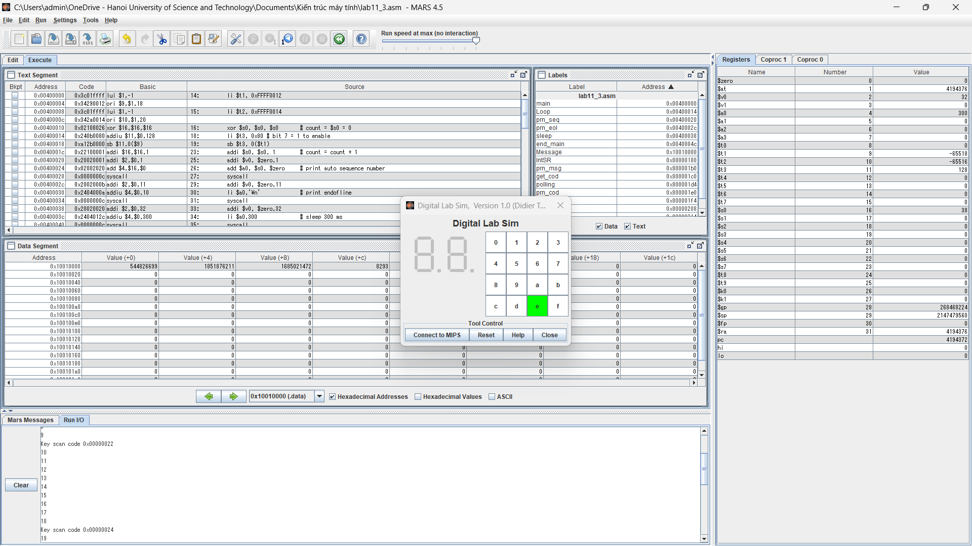
.eqv IN_ADRESS_HEXA_KEYBOARD 0xFFFF0012
.eqv OUT_ADRESS_HEXA_KEYBOARD 0xFFFF0014
.data
Message: .asciiz "Key scan code "
#~~~~~~~~~~~~~~~~~~~~~~~~~~~~~~~~~~~~~~~~~~~~~~~~~~~~~~~~~~~~~~~~~
# MAIN Procedure
#~~~~~~~~~~~~~~~~~~~~~~~~~~~~~~~~~~~~~~~~~~~~~~~~~~~~~~~~~~~~~~~~~
.text
main:
#---------------------------------------------------------
# Enable interrupts you expect
#---------------------------------------------------------
# Enable the interrupt of Keyboard matrix 4x4 of Digital Lab Sim
li $t1, IN_ADRESS_HEXA_KEYBOARD
li $t2, OUT_ADRESS_HEXA_KEYBOARD
xor $s0, $s0, $s0 # count = $s0 = 0
Loop:
li $t3, 0x80 # bit 7 = 1 to enable
sb $t3, 0($t1)
#---------------------------------------------------------
# Loop an print sequence numbers
#---------------------------------------------------------
addi $s0, $s0, 1 # count = count + 1
prn_seq:
addi $v0, $zero,1
add $a0, $s0, $zero # print auto sequence number
syscall
prn_eol:
addi $v0, $zero,11
li $a0,'\n' # print endofline
syscall
sleep:
addi $v0, $zero,32
li $a0,300 # sleep 300 ms
syscall
nop # WARNING: nop is mandatory here.
b Loop # Loop
end_main:
#~~~~~~~~~~~~~~~~~~~~~~~~~~~~~~~~~~~~~~~~~~~~~~~~~~~~~~~~~~~~~~~~~
# GENERAL INTERRUPT SERVED ROUTINE for all interrupts
#~~~~~~~~~~~~~~~~~~~~~~~~~~~~~~~~~~~~~~~~~~~~~~~~~~~~~~~~~~~~~~~~~
.ktext 0x80000180
#-------------------------------------------------------
# SAVE the current REG FILE to stack
#-------------------------------------------------------
IntSR:
addi $sp, $sp,4 # Save $ra because we may change it later
sw $ra,0($sp)
addi $sp, $sp,4 # Save $ra because we may change it later
sw $at,0($sp)
addi $sp, $sp,4 # Save $ra because we may change it later
sw $v0,0($sp)
addi $sp, $sp,4 # Save $a0, because we may change it later
sw $a0,0($sp)
addi $sp, $sp,4 # Save $t1, because we may change it later
sw $t1,0($sp)
addi $sp, $sp,4 # Save $t3, because we may change it later
sw $t3,0($sp)
#--------------------------------------------------------
# Processing
#--------------------------------------------------------
prn_msg:
addi $v0, $zero, 4
la $a0, Message
syscall
get_cod:
li $t1, IN_ADRESS_HEXA_KEYBOARD
li $t2, OUT_ADRESS_HEXA_KEYBOARD
li $t3, 0x1 # check row 4 and re-enable bit 7
polling:
sb $t3, 0($t1) # must reassign expected row
lb $a0, 0($t2) # read scan code of key button
beqz $a0, next_row # if no key pressed, check next row
prn_cod:
li $v0,34
syscall
li $v0,11
li $a0,'\n' # print endofline
syscall
next_row:
sll $t3, $t3, 1 # shift left to check next row
ble $t3, 0x8, polling # loop until all rows checked
j next_pc
#--------------------------------------------------------
# Evaluate the return address of main routine
# epc <= epc + 4
#--------------------------------------------------------
next_pc:
mfc0 $at, $14 # $at <= Coproc0.$14 = Coproc0.epc
addi $at, $at, 4 # $at = $at + 4 (next instruction)
mtc0 $at, $14 # Coproc0.$14 = Coproc0.epc <= $at
#--------------------------------------------------------
# RESTORE the REG FILE from STACK
#--------------------------------------------------------
restore:
lw $t3, 0($sp) # Restore the registers from stack
addi $sp, $sp, -4
lw $t1, 0($sp) # Restore the registers from stack
addi $sp, $sp, -4
lw $a0, 0($sp) # Restore the registers from stack
addi $sp, $sp, -4
lw $v0, 0($sp) # Restore the registers from stack
addi $sp, $sp, -4
lw $ra, 0($sp) # Restore the registers from stack
addi $sp, $sp, -4
return:
eret # Return from exception

